Minutes of the general meeting held Tuesday, February 9, 2021

Opening
Tammy P. opened the meeting and welcomed all in attendance at 6:38pm.

Present: Jessica Dunn, Sherri Brunke, Stacey Seed, Richelle Skiller, Trina Morley, Codie Hughes, Amandeep Kaur, Phuong Tran ‘Fawn’, Kelda Krafft, Jason Hubner, Vicki Stibbard, Tammy Pengelly, Lisa McAulay

Apologies: Col Morley, Julie Blake, James Watt, Regan Cunningham, Gina Hawkins

The minutes of the previous meeting held Tuesday, November 10, 2020, were distributed by Jessica Dunn via email to all members. A hardcopy was read by those at the meeting who had not seen this. Jess D. moved and Stacey S. seconded that the minutes be adopted as a true and correct record, and the motion was carried.

Business arising from the minutes

Nil

Correspondence since the previous general meeting
Inward (as listed)
- Remittance Advice – Containers for Change
- Muster - 2021
- Brownlow and Macaulay – Accountants - Lisa

Outward (as listed)
- Lisa accountants

Business arising from correspondence:
Nil
Moved by Jess D. and seconded by Lisa M. seconded that the inward correspondence be received and the outward endorsed and the motion was carried.

Principal/Deputy Report, and any business arising from this:

Asbestos Training
Stacey Seed presented the Asbestos Training via the Learning Place to the P&C. The asbestos video was observed and discussed by those present.

Treasurer’s report and financial statement, and any business arising from these:

Cash Flow Management report and budget overview was received from Business Services Manager at the meeting.
The Treasurer’s report was received at the meeting. Future payments, purchases and orders were approved as listed.

.

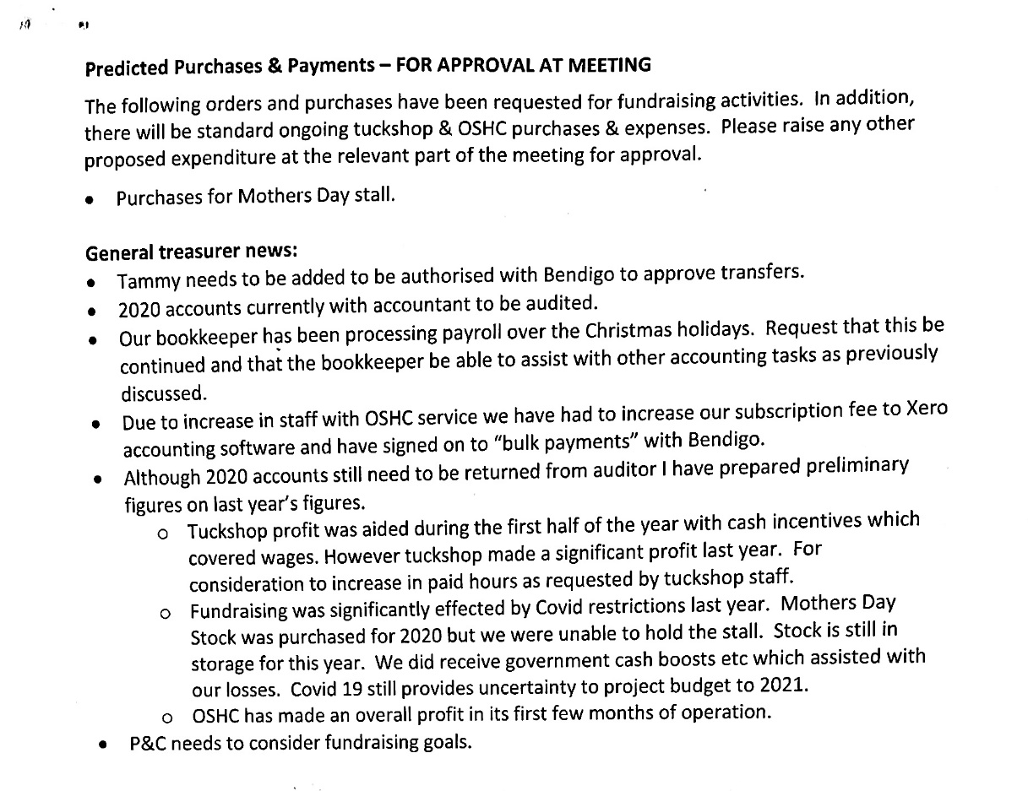
Lisa M. moved the motion at P&C continues to pay Sherri Brunke for bookkeeping duties of up to 10 hours per week. All agreed and the motion was carried.

Moved by Lisa M. and seconded by Kelda K. seconded that the inward correspondence be received and the outward endorsed and the motion was carried.

Fundraising Report, and any business arising from this:

The following are events we could possibly run for the year
- EASTER RAFFLE- Drawn the 24th March last parade
- MOTHERS DAY STALL – Thursday 6th March
- DISCO ? – None at this stage
- PIE DRIVE – Delivery dates 24th June and 2nd December
- SPORTS DAY – 25th June, Tuckshop ladies are taking this on
- FATHERS DAY STALL – Thursday 2nd September
- X-MAS BBQ and Raffle – if restrictions are lifted
- BUNNINGS BBQ – REQUIRES 5-6 PEOPLE PER SHIFT will hold off until second semester
- MUSTER - In discussion
- COLOUR RUN – Bek Crow organising no date as yet
- READ A THON – in conjunction with book week (August)
- SENIOR TILES - September
- GRADUATION BEARS - November

There are sales for the Mothers and Father’s day stall on at the moment.

Keld K. sought permission to use up to $3000 to spend purchasing items for the Mothers/Fathers’ Day stalls while items were cheaper. All agreed.

Kelda K. moved and Stacey S. seconded that the Fundraising report be accepted.

Tuckshop Report, and any business arising from this:
Trina M. moved the motion that the tuckshop employs the second convenor on Fridays. This would mean that one convenor is paid 3 days a week and the other 2 days a week. All agreed and the motion was carried.

Trina M. moved and Sherri B. seconded that the Tuckshop report be accepted.

OSHC Report

OSHC Update
OSHC has started very busy this year. We have over 100 enrolments and 98 of those are in the OSHC. The others are students who use our vacation care that attend other schools. The numbers have certainly grown since the 40 children we enrolled in October last year. We average nearly 20 children in the mornings and around 27 in the afternoon. Some afternoons we have 35 and over children. On these afternoons I have been volunteering along with Jason Hubner, Vicki Stibbard and Stacey Seed has also lent us an afternoon. While I thank these wonderful people very much I am actively looking for more staff. We have interviewed and have a new educator starting this Thursday in the PM session. Her name is Clare Wengert and she has a Diploma Early Childhood Education
and Care and is studying to be a teacher. While Clare is quite young she has relevant experience in the industry. It is hoped that in time, Clare will become an assistant Co-ordinator and able to step up when Karlie is not available. The ladies in the office are becoming very efficient at enrolling new families and are able to answer many of their queries. We have decided to coincide the emergency evacuations and lockdowns with the school. They means that they will all happen on the same day.
Vacation Care
I feel that the vacation care was a resounding success. I know not everything is where/how we would like it to be but what a wonderful learning curve. The staff who worked during this time are to be congratulated on their simply awesome efforts. The service was only 10 weeks old when we entered the vacation sessions. We have had a feedback meeting since then and that information is on the following page. We had students from other schools attending and families who had moved service (because it was closer to their work) return as their students enjoyed it far more with Koala Kids.
ECEC Visit (Early Childhood Education and Care)
On Thursday 18 February, Alison Duggan, Early Childhood Officer from the Maryborough Regional Office/ North Coast Region Department of Education will visit our service. While it is purely a voluntary thing for us to participate in, I do believe that it is an excellent chance for us to collaborate with this department and receive the support that we may need. The idea is that we discuss where we feel we need help and they will help/guide us to the places/people that may be able to network with us. Alison invited the 4 Approved Providers to the meeting but I explained that as people working fulltime jobs that this may not be possible. I thought that it would be great to have Vicky Stibbard, James and Stacey attend if they wish. However, if you have anything you think we need to discuss with Alison, please let me know. Alison will also help us ensure that the goals in our QIP are attainable and met. Alison will assess our service on the day and if anything she finds on the day is non-compliant, then we will need to fix it as a matter of priority. I’m hoping with this type of collaboration we will be able to keep our Exceeding rating.
OSHC Subcommittee
I am hoping that the OSHC Subcommittee could have a person organise the meeting times, collate the agenda and type up the minutes to distribute. I am more then happy to continue to manage the OSHC (and as I am part the Approved Providers, probably necessary) and to lead the meetings, I just need some support getting things organised. I am hoping that we will address items from our QIP and the areas of the Policy and Procedures that are also mentioned in the QIP. I have two people in mind and will discuss with them before the AGM.

This is the end of the report but I am so proud of my team and how we have continued to grow our service and would just once again like to thank everyone for their support.

Vacation Care Feedback Meeting 8/1/201
Attendees – James Watt, Grace Garrett, Stacey Seed, Tammy Pengelly, Vicky Stibbard, Rebecca Adamson, Jeanene Munn.

Behaviour
- Need an activity board
- Structure the day better
- Sperate the ages
- Routine
- Traffic Lights / Token System
- Sit students down and explain expectations and next activity
- How to communicate behaviour between shifts and also parents
Bags were a mess in the corner
- We now have a bag rack and it’s just waiting to be painted
Communication and Planning
- Need team meetings
- Emails
- Better inductions
- Better planning – so correct amount of resources are available
- Need more kitchen resources
Communication with Parents
- Facebook
- Survey to parents re vacation care
- See Saw app working?
Sign in/out for parents
- Need to be vigilant who is taking the children
- Parents need to sign out the child either in the app or manually
- Ipad needs to be more accessible
- Need to communicate the processes clearer to parents
Enrolment process complicated for some.
- Unfortunately, it may not be a good move to change this system just yet as most parents are fully set up and have bank details, CCS flowing though this service. The ladies in the office are very efficient at helping book the children in and out if necessary. We can all help enrol students.
Policies need to be better understood by all staff before starting
Cleaning plan needs to be better organised next time for both the hall and the library
Training needs to be updated. Jeanene and Leonie have sent in more comprehensive feedback that should be presented at the next OSHC subcommittee meeting.

Motions on Notice
Nill

General Business

Welcome Letter
Jess D. proposed the P&C create a welcome letter to send home to families. Jess D. to complete by next meeting.

Codie
Codie H. has made the decision stand down from the Tuckshop Convenor role for the remained of 2021. Please see appendix for her letter.
New Members

Nil

Date of next meeting – March 23, 2021 6:30 at the Library

Close – Tammy P. closed the meeting, 8:36pm.

Appendix

